PRT661 – Data Science Practice
Stage 2 Preprocessing, Feature Engineering
and WP2 Contribution Progress Report
Australian Electricity Demand Forecasting Using Machine Learning and Time-Series Analytics

Team | Project Stage | Evidence Run
Dan6 / Group 2 | Stage 2 – Preprocessing & Feature Engineering | Stage2_Preprocessing_Output_20260914_150854

Student | ID | Primary Stage 2 role
Ashish Shrestha | S388084 | Forecasting / Feature Engineering Lead
Bishal Dahal | S388095 | Verification & Dashboard Lead
Sudip Lamichhane | S388085 | Data Acquisition & Correction Handling Lead
Suraj Raut | S391201 | Data Engineering Lead

Prepared from the initial preprocessing design, four individual WP2 reports, four individual code modules, the integrated final pipeline, Stage 1 input package, and the verified Stage 2 output.

1. Executive Summary
Stage 2 converted the project from a collection of heterogeneous electricity, weather and calendar source files into a controlled modelling handoff. The final pipeline is not only a cleaning script: it is the information boundary between raw acquisition and Stage 3 forecasting. It standardises six Australian electricity regions to a common 30-minute analytical grid, engineers forecast-safe demand/calendar/weather features, prevents the prediction month from leaking into training, validates every transformation, and packages the evidence needed for reproducible modelling.
Current verified outcome
The attached Stage 2 run reports 162/162 core checks PASS, 60/60 live-weather checks PASS, and all 6/6 regions READY. Feature Set A contains 39 core predictors and Feature Set B contains 54 predictors after adding weather/context variables. Training ends at 2026-08-31 23:30:00 and the prediction period begins 2026-09-01 00:00:00.

The four individual WP2 documents were written against an earlier integration snapshot. Their ownership claims remain useful, but numerical values that changed during final integration—especially Feature Set B size, live seven-day forecast handling and the strict previous-month cutoff—are updated in this consolidated report from the final Stage 2 output rather than copied from the earlier reports.
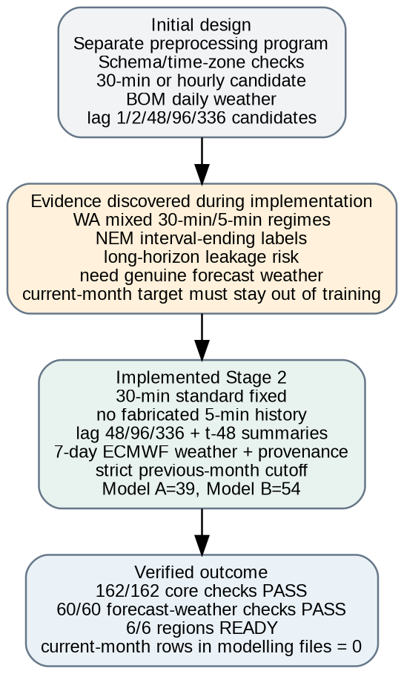
Figure 1. Plan-to-reality progression: the initial preprocessing proposal was refined when source-frequency, forecast-safety and leakage issues were discovered during implementation.

2. Evidence Base and Scope of This Update
This report consolidates the development trail rather than treating the final script as if it appeared in one step. The evidence set reviewed for the update is shown below.
Evidence type | Artefact | How it is used
Initial plan | Preprocessing Design(1).docx | Proposed sequencing, frequency harmonisation, missingness, feature candidates, leakage rules and 2026 validation approach.
Individual WP2 reports | 4 DOCX files | Original responsibility, issues found, functions developed, peer dependencies and reflections.
Individual WP2 code | engineering_suraj.py; source_quality_sudip.py; features_ashish.py; validation_bishal.py | Direct technical evidence of separate module development before integration.
Integrated code | Preprocessing final / latest 02_Preprocessing.py | Final single-pipeline behaviour including strict cutoff, live forecast weather, provenance and atomic Stage 2 ZIP handoff.
Stage 1 input | Data(1).zip | Demand, weather, public holidays, dispatch/predispatch, WA requirements and archived/latest forecast-weather vintages.
Stage 2 output | Stage2_Preprocessing_Output_20260914_150854.zip | Model-ready files, validation, feature contracts, analysis figures and metadata used for the quantitative evidence in this report.

3. Initial Stage 2 Design and Work Allocation
The initial design deliberately separated acquisition from preprocessing. It proposed schema checks, time-zone handling, frequency assessment, aggregation to a consistent modelling interval, missing-value analysis, anomaly checks, weather and holiday joins, lag/rolling features and chronological train/validation/test handling. This provided a sound plan, but several implementation details had to be strengthened once the real source data and long-horizon forecasting constraints were observed.
Initial design responsibility | Assigned lead | Reason for assignment
Schema, frequency, time alignment and common grid | Suraj Raut | Data engineering responsibility and continuity from the acquisition schema work.
Duplicates, gaps, corrections, WA source regimes, holidays | Sudip Lamichhane | Source-quality and correction-handling responsibility.
Rolling analysis, demand/weather features, forecast-safe feature contract | Ashish Shrestha | Forecasting responsibility and need to design features around future information availability.
Independent before/after tests, readiness and output validation | Bishal Dahal | Verification responsibility; tests should be independent from the transformation being tested.
Feature engineering contract and integration | All four | Features depend simultaneously on the clean grid, source integrity, future-safe logic and independent verification; the final contract cannot be owned in isolation.

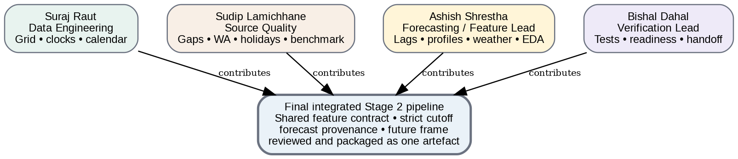
Figure 2. WP2 collaboration model. Each member delivered a specialist module, while the final Stage 2 pipeline and feature contract were integrated jointly.

4. From Proposed Design to Implemented Pipeline
Design item | Initial proposal | Final implementation | Why the change matters
Modelling interval | 30-minute or hourly was initially a candidate. | 30-minute grid fixed for all six regions. 5-minute data are aggregated by mean; older 30-minute WA data are retained, never fabricated to 5-minute. | Provides a uniform lag structure while preserving source meaning.
WA frequency | Plan recognised mixed frequencies. | Monthly resolution detection plus source-aware 30→5 minute regime handling and an explicit 16-half-hour changeover gap. | Prevents false missingness and invalid upsampling.
Short lags | lag 1 and lag 2 were early candidates. | Production set uses lag 48, 96 and 336 plus t-48-anchored summaries. | Avoids a long recursive forecast depending on thousands of unavailable one-step observations.
Weather | Daily BOM-style weather was the original concept. | Historical observed/reanalysis weather plus hourly/daily seven-day ECMWF forecast, forecast provenance and climatology fallback. | Makes Model B operationally usable without future observed-weather leakage.
2026 data use | Available 2026 actuals were initially described as validation/tuning data. | Strict previous-month cutoff: current prediction-month demand is excluded from modelling files and reserved for verification only. | Creates a clearer operational information boundary and reproducible monthly run.
Predispatch | Potential context if leakage-safe. | Retained as benchmark only; never a predictor. | Avoids circular comparison and target-definition contamination.
Feature engineering | Proposed as a distinct downstream module. | Integrated inside Stage 2, but still exported through explicit Feature Set A/B contracts for Stage 3. | Keeps the handoff simple while preserving responsibility boundaries.
Packaging | General reproducibility requirement. | ZIP written to .partial, reopened/CRC checked, required artefacts verified, then atomically renamed. | Prevents Stage 3 from selecting an incomplete archive.

5. Final Stage 2 Pipeline Architecture
The architecture below shows the implemented sequence. The important point is that no later stage silently corrects or hides an earlier problem: source quality is handled before harmonisation, the 30-minute grid is established before lags are trusted, features are built before validation, and Stage 3 receives only a validated handoff.
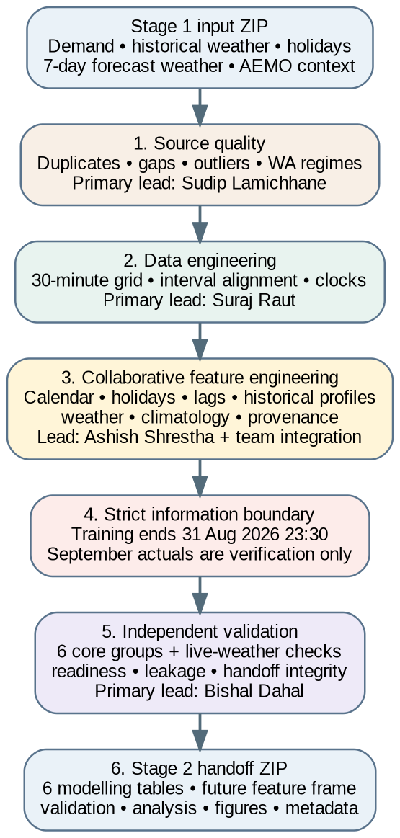
Figure 3. Final Stage 2 architecture and primary responsibility at each step.

6. Pipeline Operation Explained for a Non-Technical Reader
Step 1 – Read the Stage 1 package. The pipeline locates the real data folders inside the ZIP and loads five NEM demand histories plus WA, historical weather, the latest rolling weather forecast and public holidays.
Step 2 – Check source integrity. Duplicate timestamps, missing intervals, impossible values and statistical extremes are identified. Small gaps may be interpolated only within the configured limit; longer gaps remain visible.
Step 3 – Put every region on a trustworthy time grid. Five-minute demand is averaged into 30-minute demand because MW is a power level. WA native 30-minute periods remain 30-minute. Market clocks and local civil calendars are both retained.
Step 4 – Build calendar and holiday context. The pipeline derives half-hour index, hour, weekday, month, cyclical time encodings, weekends, public holidays and day-before/day-after holiday flags.
Step 5 – Build demand-history and seasonal features. The model is given prior-day, prior-week and historical seasonal context using only past information. Long-horizon features are anchored at t-48 or earlier.
Step 6 – Add weather safely. Historical rows learn from observed/reanalysis weather. Future rows use genuine seven-day forecast weather where available and climatology fallback outside that live horizon. Provenance fields record which source supplied each future row.
Step 7 – Enforce the forecast information boundary. For the September 2026 run, modelling data stop on 31 August 2026 at 23:30. September actual demand is kept separately for later verification and cannot enter model training.
Step 8 – Validate independently. Six core test groups plus a separate weather-forecast test suite check the data transformation, leakage rules and output readiness.
Step 9 – Package the Stage 3 contract. The pipeline exports region modelling files, the future feature frame, feature definitions, validation tables, analysis figures, metadata and benchmark-only AEMO context into a validated ZIP.

7. Collaborative Feature Engineering
Feature engineering became the clearest example of team integration. It is not accurate to describe the final 54-feature Model B contract as one person’s isolated work: each feature family depends on other members’ preprocessing outputs, and Bishal’s tests determine whether those features are safe to hand to Stage 3.
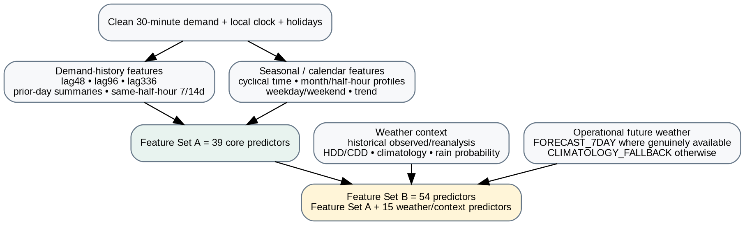
Figure 4. Collaborative feature-engineering architecture leading to Feature Set A and Feature Set B.
Feature family | Examples | Team contribution | Purpose
Demand lags | lag_48, lag_96, lag_336 | Ashish lead; Suraj grid dependency; Bishal leakage validation | Daily/two-day/weekly memory without using immediate future-unavailable observations.
Demand summaries | previous-day mean/peak/min; same-half-hour 7/14 day mean; t-48 rolling mean/std | Ashish lead + Bishal validation | Adds stable recent context for recursive long-horizon forecasting.
Calendar/cyclical | half-hour, hour, weekday, month, quarter, day-of-year, sin/cos encodings | Suraj primary; Ashish consumes in feature contract | Represents recurring time-of-day, weekly and seasonal behaviour.
Holidays | public holiday; day before; day after | Sudip primary; Suraj local-date alignment; Ashish/Bishal use and test | Captures known behavioural changes around holidays.
Historical profiles | month/half-hour means/medians; DoW profile; daily mean; peak; variability | Ashish lead; team reviewed leakage boundary | Provides stable long-horizon structure after recursive lags begin to depend on earlier forecasts.
Trend | time_index, days_since_start, year | Ashish lead | Allows models to represent gradual level shifts over 2022–2026.
Weather inputs | temperature, humidity, daily max/min/mean/rainfall | Ashish feature design; Sudip provenance; Suraj time alignment; Bishal validation | Creates a consistent numeric weather space for historical learning and live future inference.
Weather context | weather lags, rolling temperature, HDD/CDD, climatology, rain probability | Collaborative integration | Extends weather information safely beyond the detailed forecast horizon.

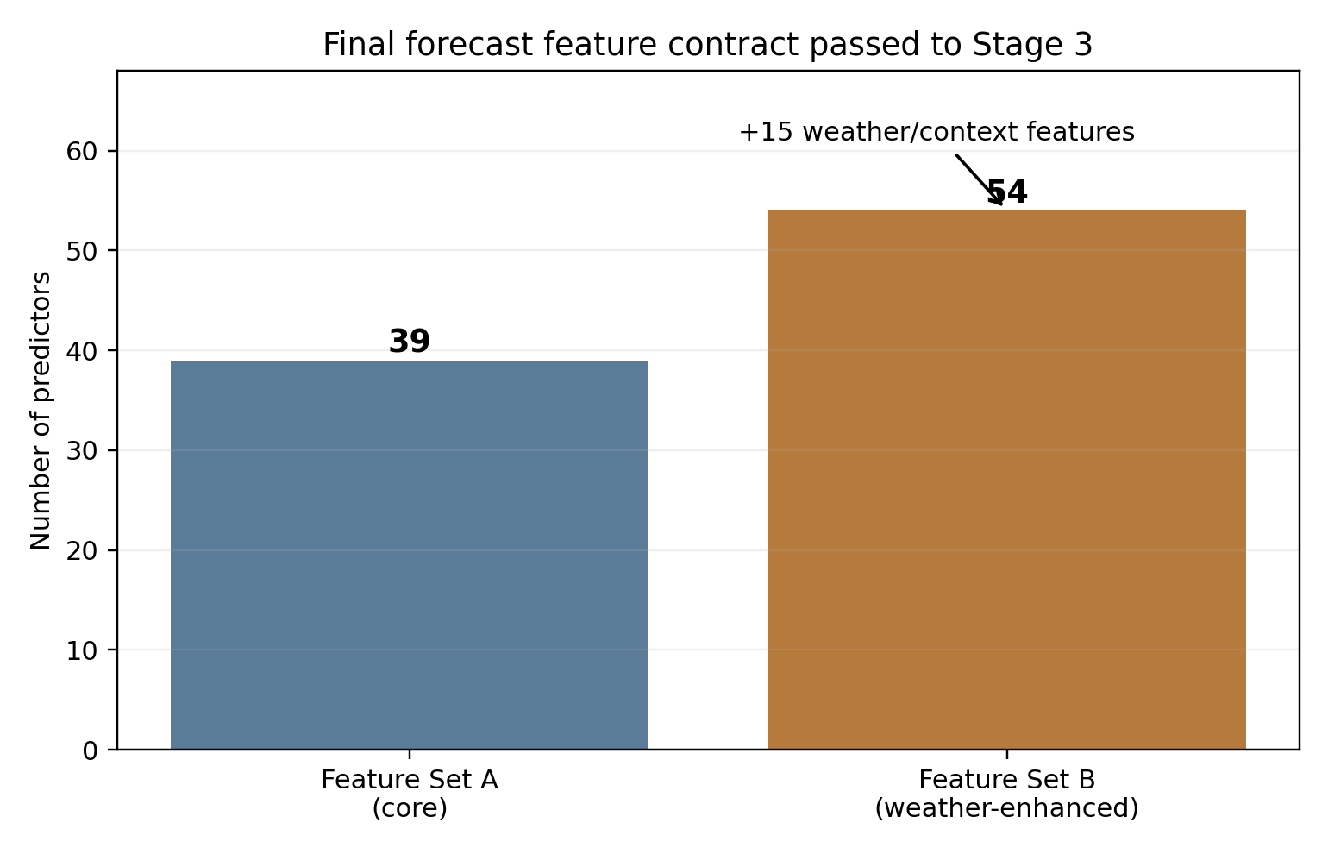
Figure 5. Final feature contract: 39 core predictors in Model A and 54 predictors in weather-enhanced Model B.

8. Strict Previous-Month Training Cutoff and Leakage Control
A major final-stage improvement was to stop each region’s modelling file at the previous complete month. This is stronger than simply training up to the newest row because it makes repeated runs in the same prediction month use the same training boundary and prevents the model from seeing any part of the month it is asked to predict.
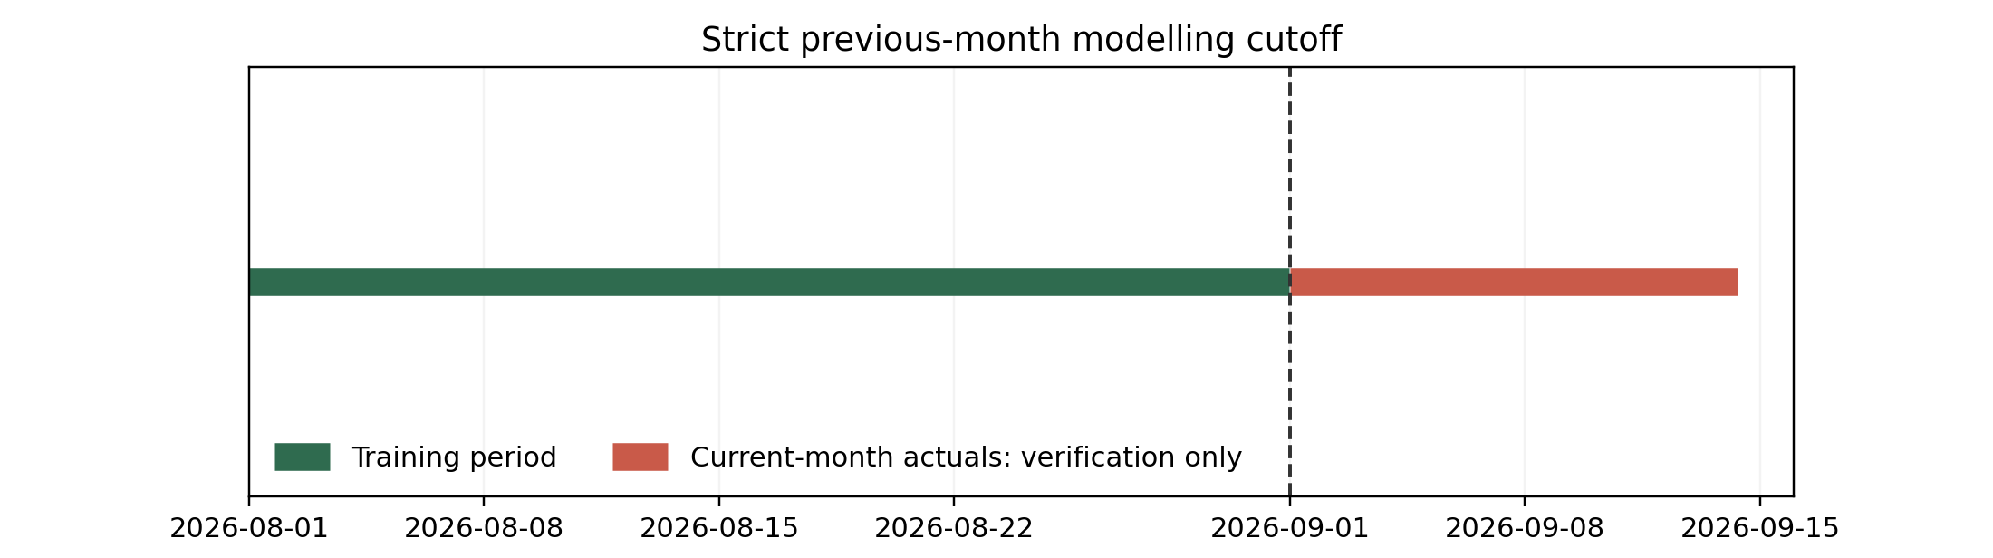
Figure 6. September 2026 information boundary. September actuals can be used for verification but not training.
Region | Required training cutoff | Prediction-month rows in modelling file | Actual rows reserved for verification | Result
NSW1 | 2026-08-31 23:30:00 | 0 | 625 | PASS
QLD1 | 2026-08-31 23:30:00 | 0 | 625 | PASS
VIC1 | 2026-08-31 23:30:00 | 0 | 625 | PASS
SA1 | 2026-08-31 23:30:00 | 0 | 625 | PASS
TAS1 | 2026-08-31 23:30:00 | 0 | 625 | PASS
WA | 2026-08-31 23:30:00 | 0 | 640 | PASS

9. Validation Evidence and Data Readiness
The final run produced evidence rather than relying on statements such as “the data was cleaned.” Every region was evaluated using the same six core test groups. A separate ten-check weather-forecast suite was also run for each region.
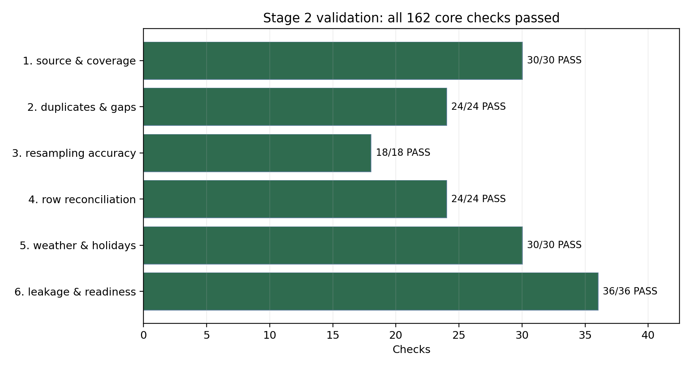
Figure 7. Core validation evidence. All 162 checks passed across the six test groups.
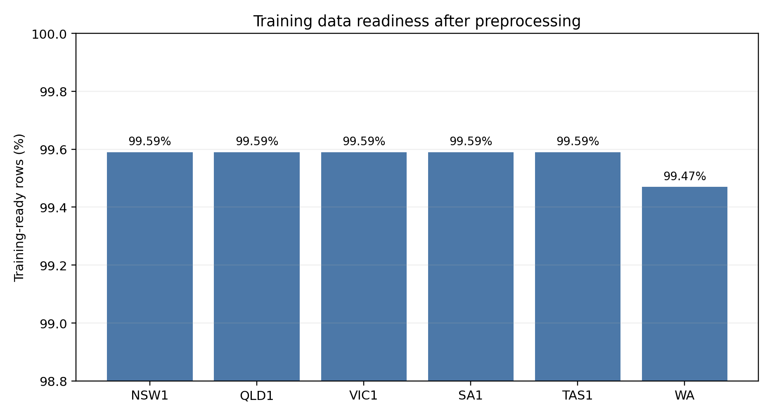
Figure 8. Percentage of region rows that remain complete for the final Feature Set B training contract.
Region | Readiness | Core checks | Training-ready | Missing demand rows | Live forecast days
NSW1 | READY | 27/27 | 99.59% | 0 | 7
QLD1 | READY | 27/27 | 99.59% | 0 | 7
VIC1 | READY | 27/27 | 99.59% | 0 | 7
SA1 | READY | 27/27 | 99.59% | 0 | 7
TAS1 | READY | 27/27 | 99.59% | 0 | 7
WA | READY | 27/27 | 99.47% | 16 | 7

WA is the only region with 16 missing demand rows in the final training grid. These correspond to the market-system changeover gap and are left explicit rather than fabricated. The readiness calculation therefore remains slightly lower for WA (99.47%) than for the NEM regions (99.59%), while the region still passes the final readiness gate.

10. Rolling Seven-Day Weather Forecast Integration
The attached Stage 1 package contains a live forecast vintage issued on 2026-09-14 00:00:00 covering 2026-09-15 00:00:00 to 2026-09-21 23:00:00 for all six regions. The Stage 2 validator confirms 7 target days, 336 half-hour forecast rows per region, valid humidity/rainfall ranges, lead days 1–7 and no future observed weather mislabeled as forecast.
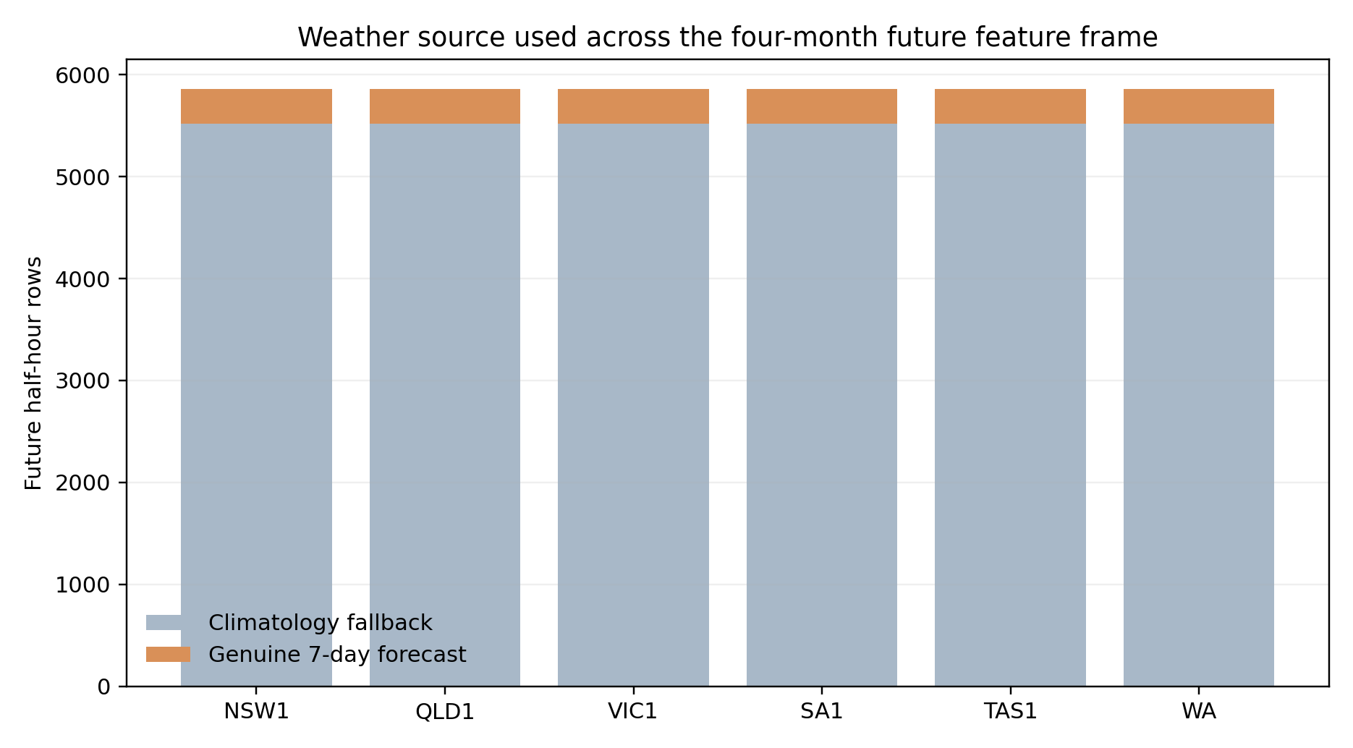
Figure 9. Future weather provenance in the four-month feature frame. Detailed forecast weather is used only where genuinely available; the remaining horizon uses climatology fallback.
Region | Weather checks | Passed | Forecast half-hours | Fallback half-hours
NSW1 | 10 | 10 | 336 | 5520
QLD1 | 10 | 10 | 336 | 5520
SA1 | 10 | 10 | 336 | 5520
TAS1 | 10 | 10 | 336 | 5520
VIC1 | 10 | 10 | 336 | 5520
WA | 10 | 10 | 336 | 5520

11. Analytical Outputs Generated by Stage 2
Stage 2 also creates exploratory evidence for the four target months. These figures are not model scores; they help explain the structure Stage 3 will model and make the preprocessing process auditable to non-technical reviewers.
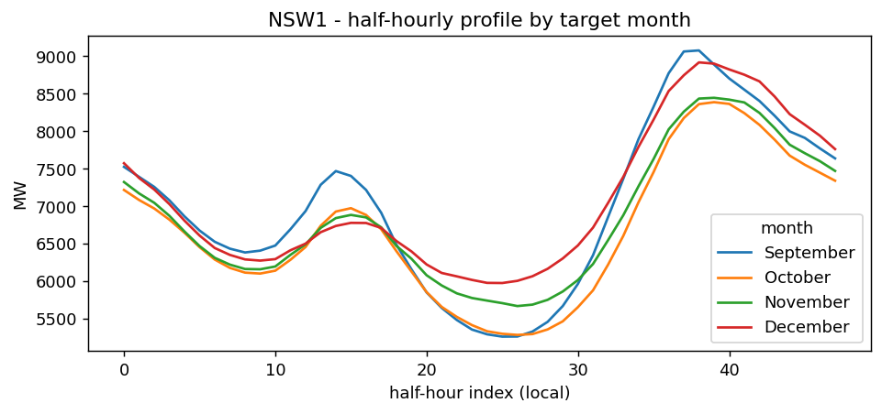
Figure 10. NSW1 half-hourly demand profile across September–December historical observations. The recurring daily shape supports time-of-day and cyclical features.
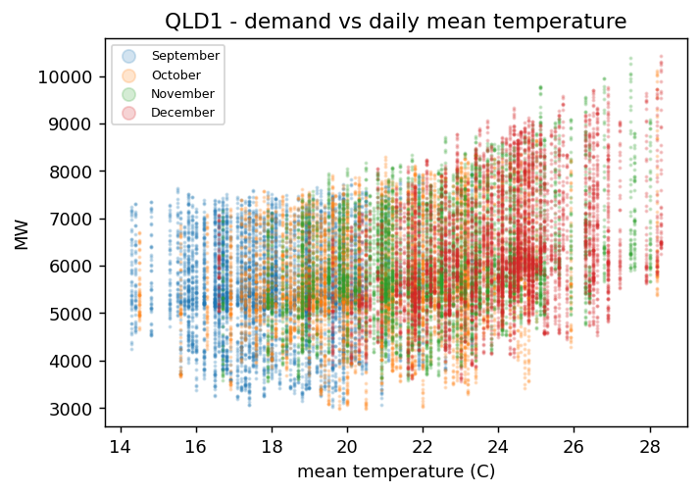
Figure 11. QLD1 demand versus daily mean temperature. The non-linear spread supports testing weather-enhanced Model B rather than assuming a simple linear temperature effect.
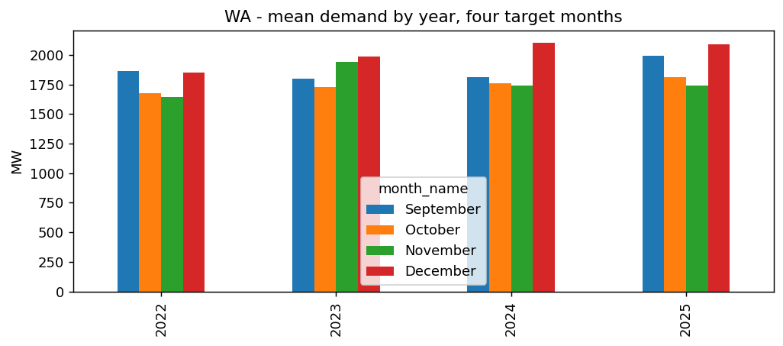
Figure 12. WA mean demand by year for the four target months, illustrating why historical month profiles and trend terms are retained.
Region | Derived balance point (°C) | Observed weather character | corr(HDD,demand) | corr(CDD,demand)
NSW1 | 19.0 | heating-driven | 0.3624 | 0.0471
QLD1 | 18.0 | cooling-driven | -0.0626 | 0.3215
VIC1 | 17.5 | heating-driven | 0.3968 | 0.0583
SA1 | 18.5 | heating-driven | 0.2513 | 0.1437
TAS1 | 17.5 | heating-driven | 0.4956 | -0.1394
WA | 19.0 | cooling-driven | 0.0826 | 0.3114

12. Updated Individual WP2 Contributions
The following summaries preserve the evidence in the original four WP2 reports while updating each member’s contribution to the final integrated pipeline. Feature engineering and later integration changes are intentionally described as collaborative where the final code depends on several workstreams.

12.1 Suraj Raut – Data Engineering Lead
Primary code carried into final pipeline: resolve_raw_root; load_nem_region; load_wa_demand; load_all_demand; detect_resolution; harmonise_to_half_hourly; enforce_continuous_grid; resolve_clocks; add_calendar_features; create_output_dirs.
Key technical contribution: Established the uniform 30-minute modelling grid without changing source meaning. NEM interval-ending alignment and WA interval handling are explicit, and missing periods are materialised so lags remain time-correct.
Collaborative feature role: Calendar and cyclical predictors rely on Suraj’s local-time/calendar engineering. Weather and holiday features also depend on the same regional clock alignment.
Independent review relationship: Sudip uses the same resolution logic for gap detection; Bishal independently recomputes resampling outputs.

12.2 Sudip Lamichhane – Data Acquisition & Correction Handling Lead
Primary code carried into final pipeline: report_duplicates; drop_duplicates; find_missing_intervals; reindex_and_flag_gaps; flag_invalid_and_outliers; load_holidays; load_holidays_covering; add_holiday_features; process_predispatch.
Key technical contribution: Preserved source integrity through the cleaning layer, including WA mixed-frequency handling, limited short-gap interpolation, explicit long gaps, holiday context and predispatch ACTUAL/FORECAST separation.
Collaborative feature role: Holiday features and source provenance are direct Model A/B inputs; weather provenance and benchmark separation were refined during team integration.
Independent review relationship: Suraj’s resolution detection is reused so cleaning and harmonisation share one definition of the native interval.

12.3 Ashish Shrestha – Forecasting / Feature Engineering Lead
Primary code carried into final pipeline: determine_rolling_window; historical_same_months; demand-history features; trend features; historical month profiles; balance-point/weather features; rolling-window EDA; month-to-date comparison.
Key technical contribution: Designed features around the forecast-origin information boundary instead of around what gives the easiest backtest score. The final feature families support recursive long-horizon forecasting and separate Model A from Model B.
Collaborative feature role: Final weather inputs, forecast provenance, climatology fallback and strict previous-month cutoff were integrated with Suraj’s time grid, Sudip’s source/holiday handling and Bishal’s safety tests.
Independent review relationship: Bishal’s leakage/readiness checks provide the independent evidence that the feature contract is safe.

12.4 Bishal Dahal – Verification & Dashboard Lead
Primary code carried into final pipeline: test_source_and_coverage; test_duplicates_and_gaps; test_resampling_accuracy; test_row_reconciliation; test_weather_and_holidays; test_leakage_and_readiness; run_core_tests; correlation_evidence; assess_readiness; data dictionary and ZIP validation.
Key technical contribution: Converted “pipeline ran successfully” into evidence of correctness by independently checking inputs, resampling arithmetic, row reconciliation, weather/holiday joins, leakage and final readiness.
Collaborative feature role: Validated the expanded 54-feature Model B contract and the new seven-day weather forecast rows instead of treating feature generation as self-validating.
Integration contribution: Final handoff validation ensures the archive is complete and safe for Stage 3 before it is published.

13. Joint Integration: How Four Modules Became One Final Pipeline
The individual module files were useful for parallel development and accountability, but the final pipeline required decisions that crossed ownership boundaries. These changes are best recorded as team integration rather than retroactively assigning them to one developer.
Integration refinement | Cross-team dependency | Final behaviour
Strict previous-month cutoff | Forecasting requirement + data engineering + validation | Training files now end at 31 Aug 2026 23:30; prediction-month actuals are exported only for verification.
Rolling seven-day weather forecast | Weather/source handling + feature design + time alignment + validation | Live forecast files are mapped to 30-minute rows with provenance and checked independently.
Feature Set B expansion | Feature design + verification | Final Model B contains 54 predictors, adding direct weather inputs and context to the 39-feature core set.
Weather provenance contract | All four | Stage 3 can distinguish OBSERVED_REANALYSIS, FORECAST_7DAY and CLIMATOLOGY_FALLBACK without using the provenance labels as predictors.
Atomic Stage 2 packaging | Verification + integration | A .partial archive is validated and CRC-checked before the final ZIP becomes available.
Current-month verification artefact | Forecasting + validation | Actual demand in the prediction month remains available for scoring while being structurally excluded from modelling datasets.

14. Problems Found During Development and How They Were Resolved
Issue | Why it matters | Resolution
Wrong resampling-bin alignment risk | NEM timestamps are interval-ending; default resampling could shift every half-hour while still looking plausible. | Source-specific bin labels and Bishal’s independent recomputation test.
WA frequency transition and apparent gaps | A single global frequency rule would misclassify the 30→5 minute regime change. | Monthly resolution inference; legacy 30-minute rows kept; 16-half-hour changeover gap remains explicit.
Feature leakage from target month | Historical profiles/current-month actuals could accidentally enter the predictor set. | Strict previous-month cutoff and explicit verification-only current-month file.
Future weather leakage | Observed target-period weather would make historical Model B evaluation unrealistic. | Forecast provenance contract; only genuine forecast weather or origin-safe climatology is used for future rows.
Incomplete ZIP selected by Stage 3 | A ZIP can exist on disk before compression has finished. | Write to .partial, reopen and CRC-check, verify required artefacts, then atomic rename.
Over-attribution of feature engineering | Feature logic depends on grid/calendar, source-quality, weather provenance and validation modules. | Final documentation treats feature engineering as collaborative and identifies primary leads rather than exclusive ownership.

15. Stage 2 Deliverables and Stage 3 Handoff
Output | Purpose
data/modelling_<REGION>_30min.csv | Six region modelling datasets ending at the strict training cutoff.
data/future_feature_frame_all_regions.csv | Current month + next three months with deterministic features, weather inputs and provenance.
validation/current_month_actuals_all_regions.csv | Prediction-month actuals kept for later scoring, not training.
validation/training_cutoff_validation.csv | Evidence that each modelling file contains zero prediction-month rows.
validation/core_validation_tests.csv | 162 transformation/readiness checks.
validation/weather_forecast_validation.csv | 60 checks proving live forecast-weather availability and safe mapping.
features/feature_set_A_core.csv | 39-feature core contract.
features/feature_set_B_weather.csv | 54-feature weather-enhanced contract.
features/weather_feature_provenance.csv | Rules describing historical training source and live future source priority.
analysis/*.csv + figures/* | EDA, correlations, weather response, month-to-date evidence.
benchmark/*.csv | AEMO source/forecast comparison artefacts retained outside the predictor sets.
metadata/run_config.json + data_dictionary.csv | Reproducibility metadata and output schema.

16. Limitations and Remaining Stage 2 Risks
Limitation | Implication / control
Representative-city weather | One city represents each electricity region, so spatial weather variation inside large regions is simplified.
Detailed weather horizon | The genuine weather forecast covers seven days; later rows use climatology fallback and should not be described as equally precise weather forecasts.
WA market changeover gap | 16 half-hours remain missing by design. This is preferable to inventing data but Stage 3 must handle the resulting incomplete rows.
Recursive forecast dependence | Even with safe long-horizon features, Stage 3 predictions eventually depend on earlier predictions; error can accumulate.
Benchmark target mismatch | AEMO predispatch TOTALDEMAND/Scheduled Demand is related context, not automatically identical to the project Operational Demand target.
Earlier WP2 reports | Individual reports represent an earlier build and therefore contain superseded counts (for example, the earlier smaller Model B feature set). This consolidated report refreshes those values from the current output.

17. Progress Evaluation and Conclusion
The initial plan proposed a separate preprocessing stage; the final implementation now demonstrates that plan as a working and auditable Stage 2 pipeline. The strongest progress is not simply that files are cleaner. The project now has a reproducible information boundary: heterogeneous source data are aligned to a common time base, long-horizon features are built with explicit forecast-safety rules, current-month actuals are structurally separated from training, live weather forecasts carry provenance, and the entire handoff is independently validated before Stage 3 can use it.
The individual WP2 workstreams remain visible in the final code, but the final result is appropriately treated as a joint integration artefact. Suraj’s engineering makes lags meaningful; Sudip’s source-quality logic makes inputs trustworthy; Ashish’s feature design makes the data forecastable; Bishal’s independent tests make the claims defensible. The feature-engineering stage therefore represents collaboration by design, not merely code merged at the end.
Stage 2 status
Evidence from the attached run supports a Stage 3-ready handoff: six regions READY, 162/162 core checks PASS, 60/60 live-weather checks PASS, zero prediction-month rows in modelling datasets, 39 Model A predictors, 54 Model B predictors, and a validated four-month future feature frame with genuine seven-day weather where available.

Appendix A. Evidence Traceability Map
Claim area | Evidence artefact(s)
Initial sequencing / proposed architecture | Preprocessing Design(1).docx
Individual ownership and reflection | Ashish_Shrestha_WP2.docx; Bishal_Dahal_WP2.docx; Sudip_Lamichhane_WP2.docx; Suraj_Raut_WP2.docx
Original modular code | engineering_suraj.py; source_quality_sudip.py; features_ashish.py; validation_bishal.py
Final integrated logic | Preprocessing_Final_Team_Integrated.py
Final run configuration | metadata/run_config.json
Core correctness evidence | validation/core_validation_tests.csv
Training boundary evidence | validation/training_cutoff_validation.csv
Weather forecast evidence | validation/weather_forecast_validation.csv
Readiness evidence | validation/readiness_summary.csv
Feature contract | features/feature_set_A_core.csv; feature_set_B_weather.csv; horizon_safe_feature_report.csv; weather_feature_provenance.csv
EDA/analysis evidence | analysis/*.csv; figures/<REGION>/*.png
AEMO secondary benchmark | benchmark/*.csv

Appendix B. Function-Level Contribution Map
Contributor | Primary functions / area | Final integration note
Suraj | resolve_raw_root; demand loaders; detect_resolution; harmonise_to_half_hourly; enforce_continuous_grid; resolve_clocks; add_calendar_features; create_output_dirs | Core functions retained essentially unchanged in final pipeline.
Sudip | duplicate/gap functions; reindex_and_flag_gaps; flag_invalid_and_outliers; holiday loaders/features; process_predispatch | Core functions retained; benchmark/holiday logic received integration updates.
Ashish | rolling window; demand-history features; trend; historical profiles; balance point/weather features; EDA; month-to-date comparison | Core feature logic retained; live forecast-weather and strict cutoff were later collaborative refinements.
Bishal | six test groups; run_core_tests; correlation evidence; readiness; data dictionary; ZIP validation | Core validation retained; live-weather validation and atomic handoff were later integrated extensions.
All four | strict previous-month cutoff; rolling forecast-weather handoff; provenance contract; final Feature Set A/B contract; final orchestration | Documented as joint integration because these behaviours cross all specialist modules.

